How To Initialize Roku® Streaming Player & Streaming Stick

Streaming Player:
Roku uses the same software for all their devices so when you master the setup for one, you master them all. We have taken the liberty of providing you with a basic setup document so you can learn how to get this device rolling for you home entertainments system.
Connecting the Roku player to your TV
All you need for your Roku streaming device is an HDMI connection. When you connect your Roku streaming device to your TV using an HDMI connection, you should ideally use an HDMI connection.
If you do have an older connection/ TV, there are some Roku models that include a standard composite video connection, as well as the HDMI.
Setting up your Roku player
- The first step is to connect your Roku streaming player directly to your TV using that HDMI Cable or composite cables.
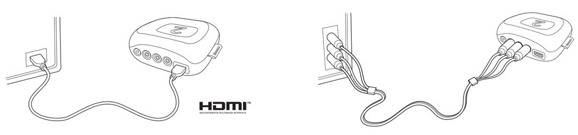
- Next, if your Roku device comes with an Ethernet port, you can use an Ethernet cable to connect your Roku device to an available Ethernet port on your router or Ethernet switch.
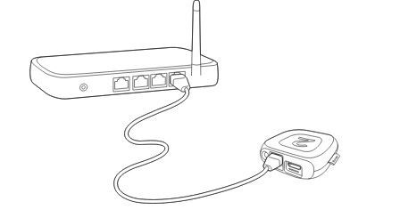
- Now, open up the battery cover from your Roku remote and insert the batteries.
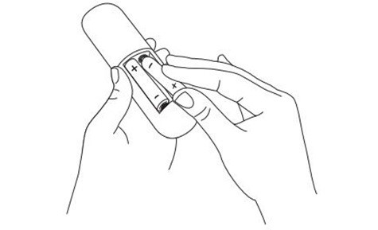
- You will also need to plug in the power connector to the Roku player and connect the power adapter to a wall outlet.
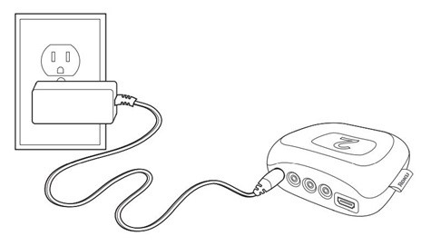
- You also need to ensure that the correct TV input is selected on your TV (the input to which your Roku player is connected). You will be able to see the Roku logo on the TV screen as your Roku player powers on. Help is available if you do not see any picture on your TV or you have problems with your remote control.
Going through Guided Setup
- Choose a language
- When your Roku Player powers on, the first screen will prompt you to choose a language. All the text that you see displayed within the Roku application will be displayed in the selected language. Scroll up and down the list and press to choose a language.
  - Note: It is the responsibility of the channel provider to translate their channel and some channels may not support your chosen language.
- Connect your Roku player to the Internet
  - Choose your wireless network from the list of available networks and enter your password. This is most often the same network you use to connect your computer or smartphone to the Internet.

  - If you want to see your password as you type, choose Show password.
  - Once you’ve entered a password and selected the “Connect” option, your Roku player will automatically connect to the Internet.
- Wait for your Roku player to download the latest software
  - Once you connect to your internet, your Roku player will check to see if a software update is available. If there is, it will download the latest version and then reboot.
- Create a Roku account and activate your Roku player
  - In order to activate your Roku player, it must be linked to a Roku account. Your Roku account will keep track of which Roku devices too. This allows you to add free and purchase channels from the Roku Channel Store.
  - The instructions for activating a Roku device will be displayed on the TV, including an activation code, for example, something like: “XCV5TG”.
  - You will also need to visit my.roku.com/link on your computer or smartphone device to enter the code and follow the online instructions to activate your Roku player.
- You are done!
Now that you’ve completed the activation steps, your Roku should will be ready to use.
Streaming Stick:
The Roku® Streaming Stick® (model: 3600) supports resolutions up to 1080p Full HD and ships with an Enhanced “point-anywhere” remote control.
Does the Roku Streaming Stick work with my TV?
The Roku Streaming Stick is able to work for any TV that has an HDMI connection.
- Note: The “Roku Ready” version of the Roku Streaming Stick (model 3400/3420) connects to the MHL port of your Roku Ready television or other type of compliant device (e.g. Blu-Ray™ player).
Setting up your Roku Streaming Stick
- Download the Quick Start Guide.
Going through Guided Setup
- Choose a language
When you power on your Roku Streaming Stick, the first screen will allow you to choose a language.
Scroll up and down the list and press to choose a language.
- Connect your Roku Streaming Stick to the Internet

  - Choose your wireless network from the list of available networks and enter your password. This is most often the same network you use to connect your computer or smartphone to the Internet.
  - If you want to see your password as you type, choose Show password.
  - Once you have entered your password and selected Connect. After this, your Roku Streaming Stick should automatically connect to the Internet.
- Wait for your Roku Streaming Stick to download the latest software
  - Once you have properly connected to the internet, your device should download the latest version of Roku’s software.
- Create a Roku account and activate your Roku Streaming Stick
  - To properly activate your Roku Streaming Stick, it must be linked to a Roku account.
  - The direction to activate your Roku Streaming Stick will be displayed on your TV, including an activation code; e.g. “XCV5TG”.
- You are done!
Now that you’ve completed all the above steps your Roku should be ready for use!

